Check for Teams without Owners

Always assign at least two owners for groups. There are two ways to do it. You can check from the Teams Admin Centre Or schedule the below script to return you the Teams without Owners regularly(weekly/monthly).

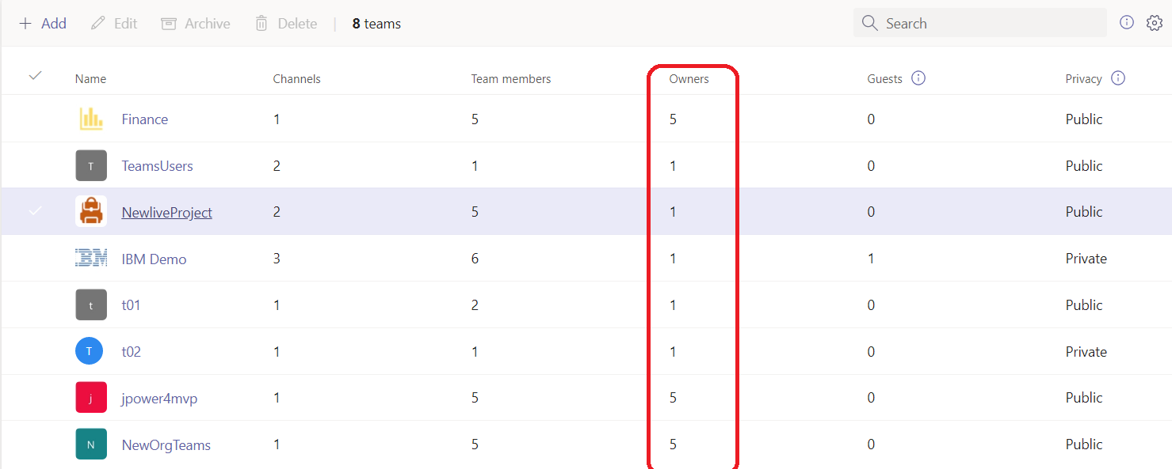

#### Check for inactive Teams

There is no direct way to check for inactive Teams. It is difficult to define inactivity universally, since there are Teams with conversations alone, Office365 Groups with SharePoint file activities or group conversations alone. There is a nice [script available in TechNet](https://gallery.technet.microsoft.com/Check-for-obsolete-Office-c0020a42), you can download and modify the script as per your need.

